Rise Park Academy Trust

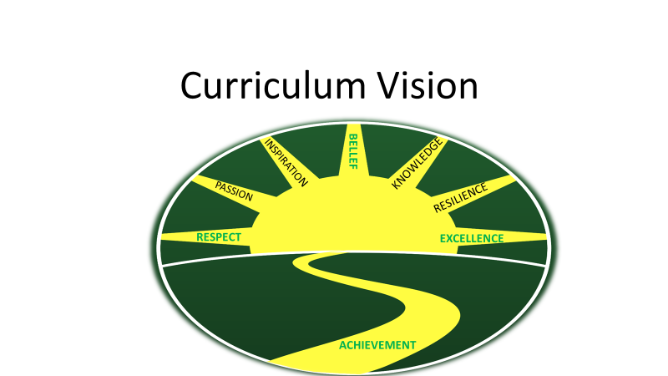

Remote Learning Policy

For: Rise Park Academy Trust

Date of Issue: January 2021
Date of Review: April 2021
Responsible Staff: Heads of School
Status: Approved by SLT/Staff
- Policy Scope:

This remote learning policy for staff aims to:
- Ensure consistency in the approach to remote learning for pupils who are not in school
- Set out expectations for all members of the school community with regards to remote learning
- Provide appropriate guidelines for data protection.

- Roles and Responsibilities:
  - Teachers
When providing remote learning, teachers must be available between 8:30am and 3:30pm.
If teachers are unable to work for any reason during this time, for example due to sickness or caring for a dependent, they should report this using the normal absence procedure. This is to contact the Heads of School on 7am on the first day of absence, via a phone call.
When providing remote learning, teachers are responsible for:
Setting work for their class and for their year group if agreed. Work should be provided maths, literacy and a foundation subject daily for a minimum period of 3 hours at KS1 and a minimum period of 4 hours at KS2. All work set should be differentiated and should be consistent across the year group. The weekly timetable for this work needs to be loaded on to the Class Dojo/Google For Education platforms at the beginning of the week, before 8:30am on a Monday. Pupils with limited access to devices should complete work online where possible, or be provided with work packs.
Live Interaction on a daily basis, via Zoom/Google Meet, with their class/classes in their year group. This should take the form of a 10-15 minute discussion on the day’s work provided, as well as reflections on the previous day’s learning, with any questions or queries answered accordingly.
Provision of pre-recorded lessons for both English and maths on a daily basis, using Google For Education, to progress to one foundation subject lesson additionally at a date to be advised.
Providing feedback on work. All completed work on Class Dojo/Google For Education should be acknowledged daily when submitted. Detailed written feedback that is actionable should be given on literacy and maths work, with a minimum of two comments per subject per week. Foundation subject work should be commented on at least once a week. Feedback can be given via the like buttons on these platforms and via the comment box. Please use Standard English, which is grammatically correct, with no text type/abbreviations used to comment on work.
Keeping in touch with pupils who are not in school and their parents. In addition to Zoom/Google Meet calls, regular contact should also be made with pupils on the Class Dojo/Google For Education platforms, via feedback, blog posts and via the messaging system.
Where pupils do not have access to devices, a regular call should be made to this pupil to check how they are getting on with the work packs provided.
Teachers should answer emails from parents/carers within working hours
(Mon-Fri 8:30am-3:30pm).
Safeguarding concerns should be reported to the DSLs immediately
via telephone call, and an e mailed disclosure form. In the event of any complaints or concerns shared by parents and pupils, the parents/pupils should be referred to a member of the SLT team, and the SLT team contacted to make them aware of this.

Pupils who do not complete home learning should be positively encouraged regularly via phone calls and/or messages from the teacher. Class Dojo points and virtual certificates should be handed out when pupils have completed work at home, as a reward.
Attending virtual meetings with staff, parents and pupils. During virtual meetings, teachers should dress appropriately. Please avoid the use of personal spaces or those with background noise and ensure that there is nothing inappropriate in the background. Use a headset and earphones where possible. All pupils should be supervised by an adult during live calls, which should be recorded by the school (Ref: Video Conferencing Risk Assessment January 2021).
Where there is a crossover of teachers working in school with those working from home, teachers will be expected to help their colleagues cover the provision of home learning and live calls to children at home. All teachers will still be responsible for providing learning in school and remote learning. Year group leaders should use their discretion when distributing tasks to their year group colleagues in order to ensure that all areas are covered.
2.2 Support Staff
When assisting with remote learning, Learning Support Assistants must be available between 8:30am and 3:15pm
If support staff are unable to work for any reason during this time, for example due to sickness or caring for a dependant, they should report this using the normal absence procedure. This is to contact the Heads of School on 7am on the first day of absence, via a phone call.
Support staff will be required to assist with remote teaching and learning, as directed by the class teacher/year group leader. This could include:
- Creating online resources, such as worksheets
- Researching and finding suitable online materials for pupils to use e.g. from the National Oak Academy or White Rose Mathematics
- Preparation of work packs for children who are not able to access the online learning
- Providing direct support to identified children, where necessary, via telephone calls or video conferencing.
Support staff will also be required to attend virtual meetings with staff, parents and pupils, where required.
2.3 Subject Leaders
Alongside their teaching responsibilities, subject leaders are responsible for:
Researching, considering and informing teaching staff on whether any aspects of the subject curriculum need to be amended in order to accommodate remote learning.
Working with teachers, who are teaching their subject remotely, to make sure all work set is appropriate, progressive and ensures adequate subject coverage.
Working with other subject leaders and senior leaders to make sure work set remotely across all subjects is appropriate and consistent, and deadlines are being set with reasonable periods of notice.
Monitoring the remote work set by teachers in their subject through regular conversations with teachers, or by reviewing work set on the home learning planning.
Alerting teachers to resources they can use to teach their subject remotely.
2.4 Senior leaders
Alongside any teaching responsibilities, senior leaders are responsible for:
Co-ordinating the remote learning approach across the school in liaison with Dr. Andrew Croft, the Remote Learning Leader.
Monitoring the effectiveness of remote learning. Through regular meetings with teachers and subject leaders, reviewing work set on the weekly home learning timetables, monitoring of how Class Dojo, Google For Education and all other online platforms are being used effectively for learning, and reaching out for feedback from pupils and parents.
Monitoring the security of remote learning systems, including data protection and safeguarding considerations.
2.5 Designated safeguarding lead
The DSL is responsible for:
- Obtaining information from staff, supply staff, volunteers, children or parents and carers who have child protection concerns and recording this information. The Safeguarding team will be supported by each school’s Emotional Literacy Support Assistant.

- Following and implementing Rise Park Academy Trust’s Safeguarding and Child Protection Policies (RPJ and RPI- September 2020)
2.6 Pupils and parents
Staff can expect pupils learning remotely to:
- Be contactable during the school day via an electronic device such as an Ipad or computer, or via the telephone
- Complete work to the deadline set by teachers

- Seek help if they need it, from teachers or support staff
- Alert teachers if they are not able to complete work.

Staff can expect parents with children learning remotely to:
- Make the school aware if their child is sick or otherwise cannot complete work
- Seek help from the school when needed
- Be respectful when making any complaints or concerns known to staff.

2.8 Directors
The Directors are responsible for:
- Monitoring the school’s approach to the provision of remote learning in order to ensure that a consistently high standard of education is provided
- Ensuring that staff are certain that remote learning systems, and all devices used for these, are appropriately safe and secure, for both data protection and safeguarding reasons.

3. Who to contact
If staff have any questions or concerns about remote learning, they should contact the following individuals:
- Issues in setting work – please refer to the relevant subject lead or Miss R McClean, Inclusion Manager
- Issues with behaviour – please refer to the year group leader
- Issues with IT – please refer to IT staff (Dr A Croft, Mr M Ammon, Miss E Beaumont, Miss R Higginson) and/or use IT log
- Issues with their own workload or wellbeing – please refer to the Heads of School, Mrs K Palmer and Miss L Carter or Miss R McClean, Inclusion Manager
- Concerns about data protection – please refer to the School Business Manager, Mr S Adams, or the Executive Headteacher, Mrs C. Fox
- Concerns about safeguarding – please refer to the DSLs for the Academy Trust, Miss R McClean (EYFS/KS1) or Miss L Carter (KS2) or, in their absence, a member of the safeguarding team, Mrs K Palmer and Mrs L Nortje.

Data protection

4.1 Accessing personal data
When accessing personal data for remote learning purposes, all staff members will:
- Access the data, via Google Drive or LGFL secure email service
- Use devices such as laptops provided by school, or personal devices as agreed by the school e.g. if a phone is used to access the Zoom/Class Dojo apps, please ensure that no personal data is screenshot or saved to a phone or a personal cloud

4.2 Processing personal data
Staff members may need to collect and/or share personal data such as e mail addresses, phone numbers as part of the remote learning system. As long as this processing is necessary for the school’s operational public duties, individuals will not need to give permission for this to happen.
However, staff are reminded to collect and/or share as little personal data as possible online. All such archived data should be deleted after a 12 month period.
4.3 Keeping devices secure
All staff members will take appropriate steps to ensure their devices remain secure.
This includes, but is not limited to:
- Keeping the device password-protected – strong passwords are at least 8 characters, with a combination of upper and lower-case letters, numbers and special characters (e.g. asterisk or currency symbol)
- Ensuring the hard drive is encrypted – this means if the device is lost or stolen, no one can access the files stored on the hard drive by attaching it to a new device
- Making sure the device locks if left inactive for a period of time
- Not sharing the device amongst family or friends
- Installing and updating anti-virus and anti-spyware software
- Keeping operating systems up to date – always install the latest updates.

5. Safeguarding
Please also see RPI and RPJ Safeguarding and Child protection policies.

6. Monitoring arrangements
The Heads of School will review this policy on a termly basis.

7. Links with other policies
This policy is linked to our:
- Behaviour Policy
- Safeguarding and Child Protection Policy
- Data Protection Policy and Privacy Notices
- ICT and Internet Acceptable Use Policy
- Online Safety Policy
- Peer-on- Peer Abuse Policy

January 2021.

